ROTARY INTERNATIONAL CONVENTION HONOLULU

6TH – 10TH June 2020

IYFR Events at Convention

House of Friendship
Opens 0900h 6th June 2020
Daily hours 0900 – 1800h 6th – 9th June 2020
0900 – 1600h 10th June 2020
‘Meet and Greet’
Waikiki Yacht Club – Saturday 6th June, 1730h
(10 minutes walk from the Conference Centre)
AGM
Room 325B, GNG Rooms, 3rd Floor, Convention Centre – Sunday 7th June, 1630h
Gala Dinner
Waikiki Yacht Club – Tuesday 9th June, 1900h
Take a tour of the Waikiki Yacht Club by using the link below: -
https://www.waikikiyachtclub.com/About-WYC/Club-Tour.aspx

IYFR POST CONVENTION CRUISE 2020, HONOLULU
JUNE 11-14 2020

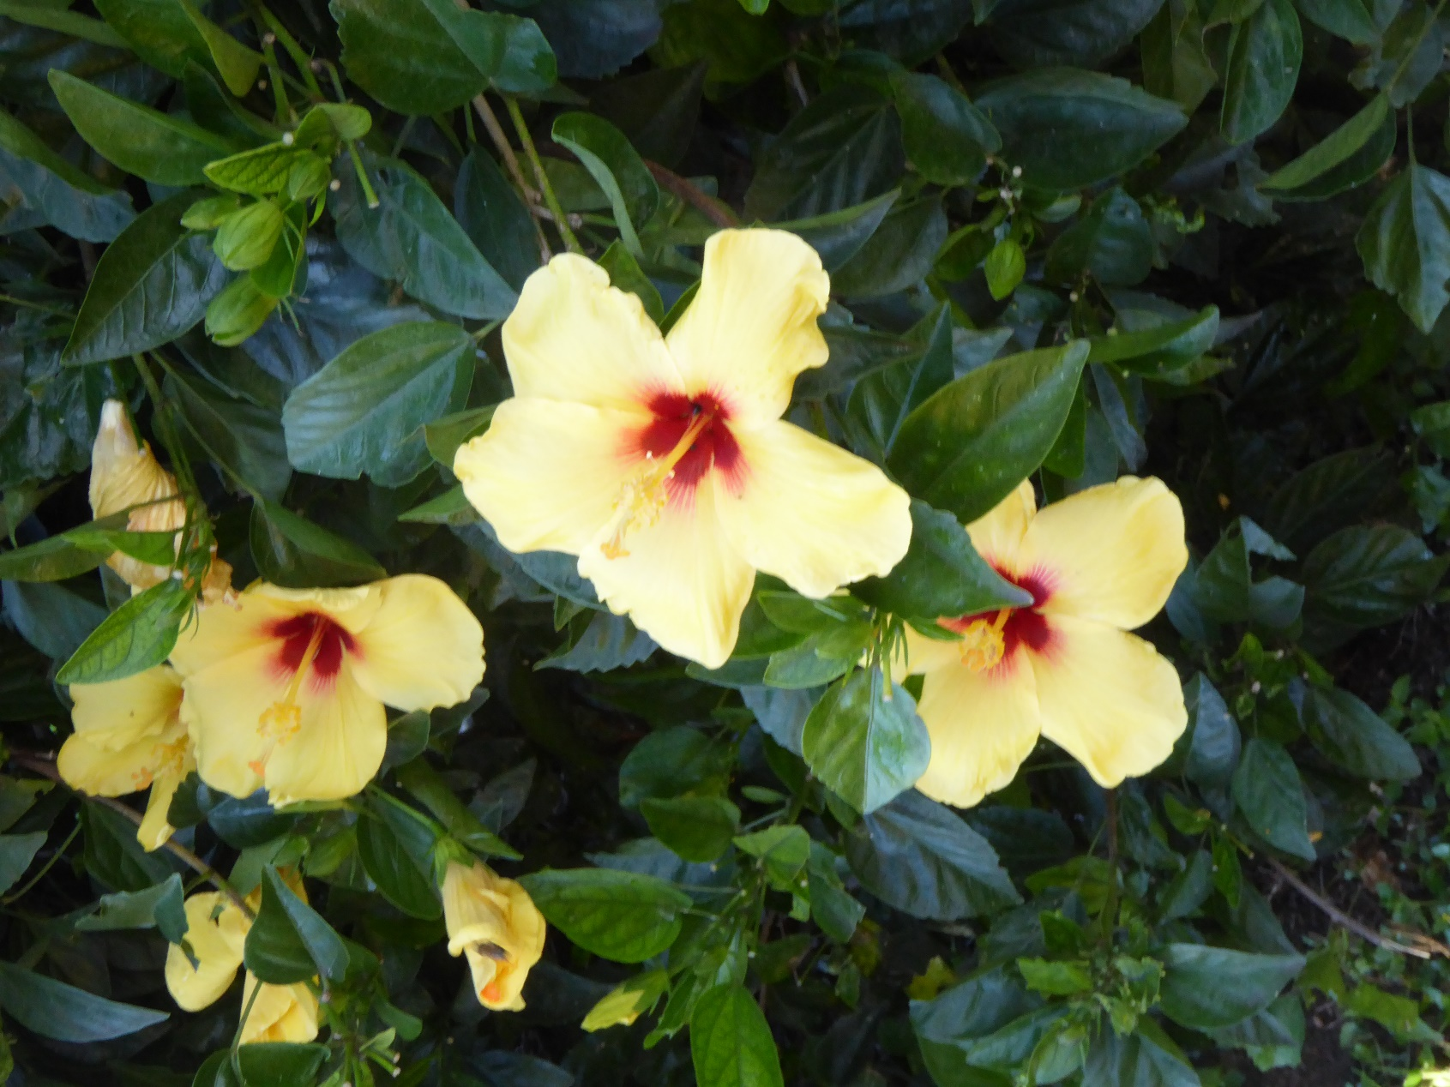

Flowers of Hawaii
June 11 Thursday – Paradise Cove Luau Dinner and Show
Time Schedule:
15:30~16:00 Depart Ala Moana Hotel
17:00~18:00 Arrive at Paradise Cove
18:00~19:00 Enjoy Hawaii Craft Demonstration
19:00 Dinner start
20:00 Show start
20:50 Depart for Hotel
21:45 Arrive at Ala Moana Hotel
Luau includes: -
- Welcome Mai Tai punch / fresh flower lei greeting
- Hawaiian dinner buffet menu consists of salad bar, broccoli & crab salad, cold steamed sweet potato, steamed white rice, island style baked chicken, kalua pig, taro rolls & butter, macaroni salad, poi, lomo lomi salmon, stir fried vegetables, beer battered Island fish, fresh pineapple chunks, various desserts & hot coffee or hot tea
- Cove card
- Games and activities
- Seating in the Orchid section of the Main Floor
- Polynesian extravaganza

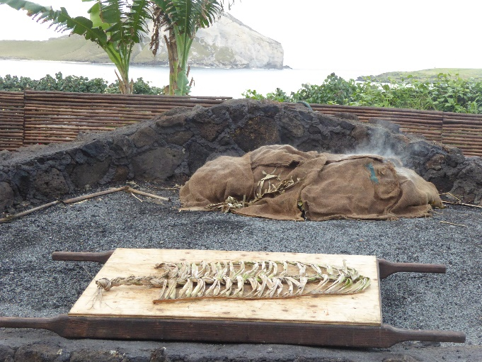 Luau Cooking Pit

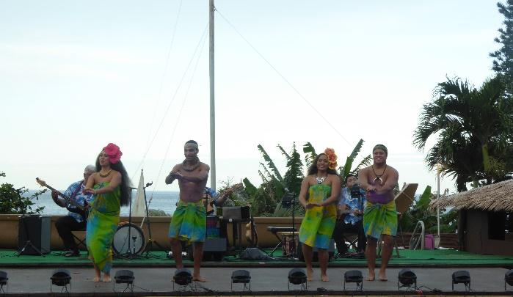 Luau welcome

June 12 Friday – Kualoa Ranch (With lunch)
Time Schedule:
08:20 Depart Ala Moana Hotel
09:00 Arrive at Kualoa Ranch Moli’I Dock
09:15 Arrive at Secret Island Beach
Enjoy beach activities (other guests will be in this area)
Ocean Voyage Tour with AniAni Catamaran – approx. 30 minutes
Buffet lunch at beach
13:30 Leave at Secret Island
14:15 Arrive at Ala Moana Hotel
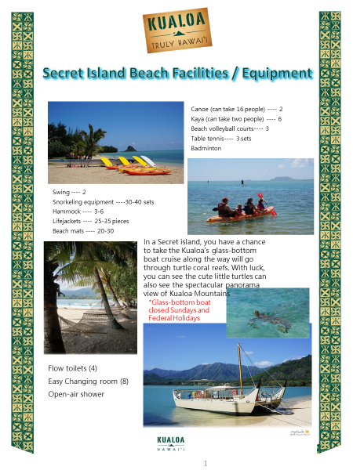

June 12 Friday - Star of Honolulu 3 Star Sunset Dinner with Fireworks Cruise

Time Schedule:
16:30 Depart Ala Moana Hotel
17:00 Arrive at Pier
17:30 – 20:30 – Dinner Cruise
21:00 Arrive Ala Moana Hotel

- Welcome non-alcoholic Sparkling Wine, and two Premium drinks each person
- Four Couse Menu (Cheeses plate, Salad, Whole Maine Lobster, Tenderloin of Beef, Dessert)
- Kona Blend Coffee or Tea
- Entertainment with Live Band Music
- Watch and enjoy Hilton Hawaiian Village Fireworks

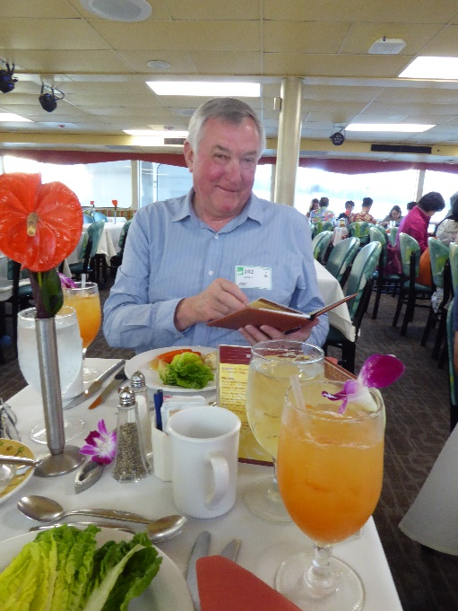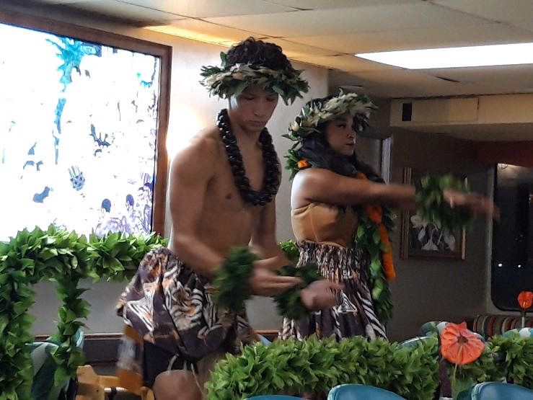

Cocktails on the Star of Honolulu Entertainment on the Star of Honolulu

June 13 Saturday – Grand Circle Island Tour (With lunch)
Time Schedule:
08:30 Depart Ala Moana Hotel
08:45 Diamond Head pass by
08:50 Kahala Area pass by
09:20 Hanauma Bay Lookout
09:40 Halona Blow Hole
10:00 Waimanalo Beach pass by
10:45 Kualoa Ranch Pass by (or rest room stop)
11:30 Lunch at Turtle Bay Golf Course
13:15 North Shore Sunset Beach pass by
13:40 Haleiwa Town (1hr of free time)
15:00 Dole Plantation
16:30 Back to Ala Moana Hotel

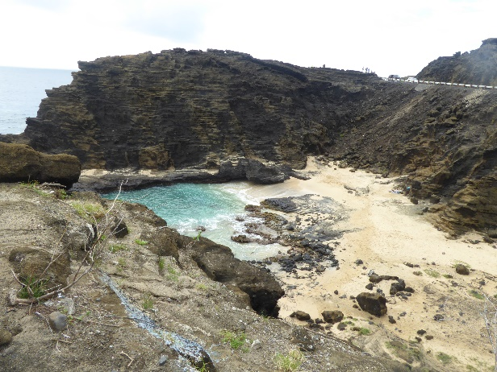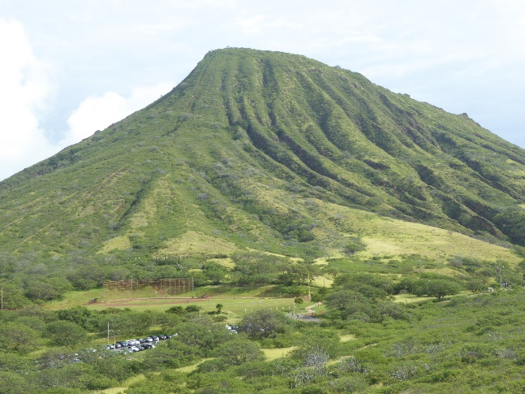

‘From Here to Eternity’ beach Diamond Head

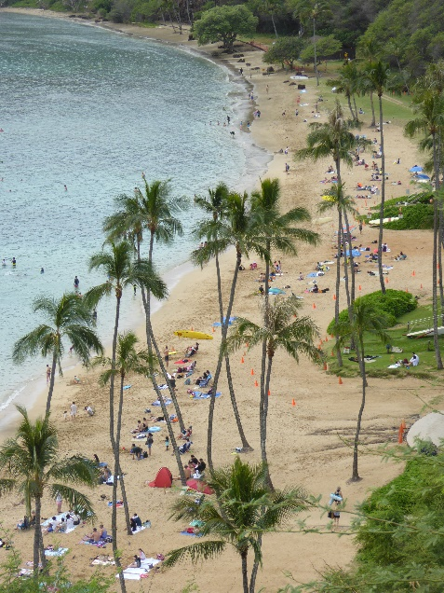 Hanauma bay Lookout

Free evening to relax

June 14 Sunday – Pearl Harbour Tour (With lunch)
Time Schedule:
09:00 Depart Ala Moana Hotel
09:30 Arrive at Pearl Harbour Visitor Center
11:30 Leave at Pearl Harbour Visitor Center
12:30 Lunch at Café Julia DownTown
(Soup or Salad, Braised Beef, Dessert, Coffee or Tea)
14:00 Arrive at Ala Moana Hotel

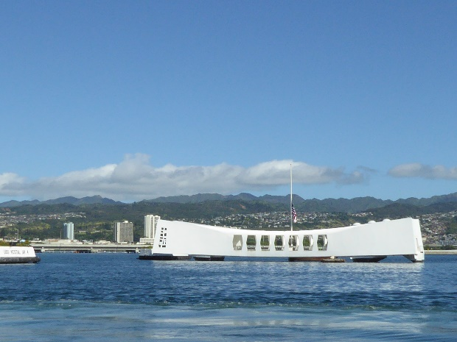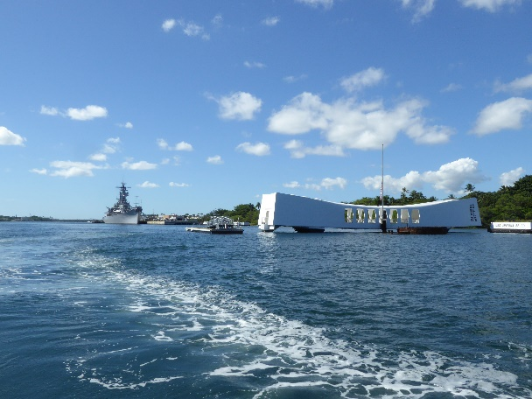
Arizona Memorial Arizona Memorial and USS Missouri
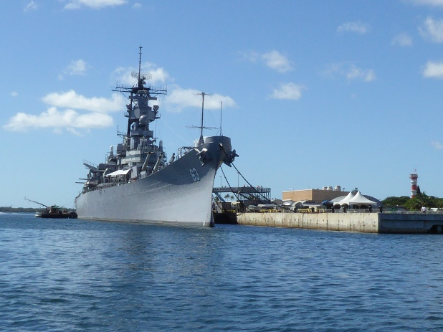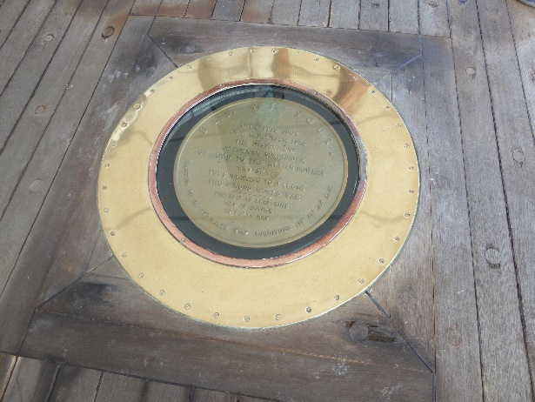
USS Missouri Spot where WWII came to an end

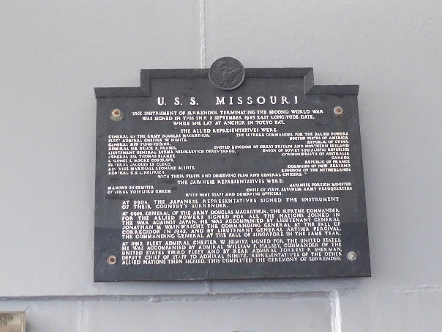
Plaque commemorating end of WWII
June 14 Sunday – Farewell dinner

The Farewell Dinner will be held in the Ala Moana Hotel

June 15 Monday – End of PCC

Carry on your own adventures

ROTARY INTERNATIONAL CONVENTION
IYFR Meetings and Post Convention Cruise
Honolulu June 2020

BOOKING FORM
First Name
Surname
Surname …………………………………………………………. First Name …………………………………………………….
Fleet
Fleet ……………………………………………………………….. Position in IYFR ………………………………………………
Position in IYFR

Address – Street ……………………………………………... City/Town ……………………………………………………….
Street
City/Town
Post Code
State/County
State/County ………………………………………………….. Post Code ………………………………………………………..
Telephone Number
Email
Telephone Number ………………………………………….. Email ……………………………………………………………….

Spouse/Partner/Guest
First Name
Surname
Surname …………………………………………………………. First Name ………………………………………………………
Fleet
Position in IYFR

For extra guests, please use a separate form
IYFR EVENTS DURING RI CONVENTION
YES NO No. Total US$
Meet and Greet – Saturday 6 June 17.30h US$55.00

AGM – Sunday 7 June 16.30h Free of Charge

Gala Dinner – Tuesday 9 June 19.00h US$95.00

(No. = Number of people)
IYFR POST CONVENTION CRUISE
YES NO No. Total US$
Post Convention Cruise – 11th – 15th June 2020 US$870.00

I have booked the Ala Moana Hotel for the PCC

Please send completed forms to Annette Lewis, email: annette-lewis@ntlworld.com

ACCOMMODATION

Rooms have been reserved in the Ala Moana Hotel at a group rate of US$185.00 plus taxes (Kona Tower) and US$205.00 plus taxes (Waikiki Tower).
Details of the hotel can be viewed on the hotel website www.alamoanahotelhonolulu.com
Please book rooms directly with the hotel, using the website : https://book.passkey.com/e/50001043

PAYMENT FOR HONOLULU EVENTS

BANK TRANSFER

To:-
Bank : HSBC
Bank Address: 2 Buchanan Street, Glasgow, G1 3LB, Scotland, UK
Account Name: International Yachting Fellowship of Rotarians
Recipient’s Address: 76 Lomond Road, Wemyss Bay, PA18 6DP, Scotland, UK

Dollar Account
Account Number: 76723060
Sort Code: 40-12-76
IBAN: GB26HBUK40127676723060
BIC/SWIFT Code: HBUKGB4B

Please state on payment, Reference – ‘IYFR Honolulu’

Payment for the ‘Meet and Greet’ and ‘Gala Dinner’ must be made in full at the time of booking.

The ‘Post Convention Cruise’ requires at least a deposit of US$ 250.00 at the time of booking, with the balance of payment to be made before the 1st May 2020.

