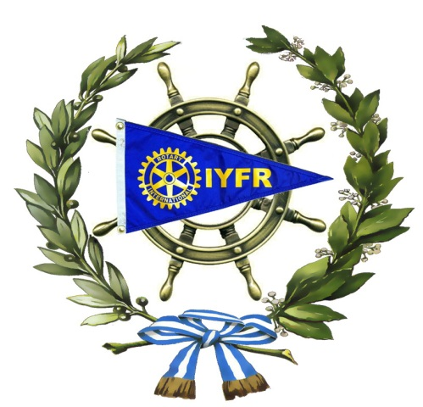
GUIDELINES FOR FLEET CHARTERING

These guidelines have been written to assist a group of Rotarians who wish to form a new Fleet.
Those actions listed below that are compulsory are noted as such, other actions are much more adjustable and can be varied according to local custom, practice and the new members wishes.
- Membership: The IYFR Rules (available on the IYFR website, www.iyfr.net) set out who may become members of a new Fleet.[compulsory]
- Fleet size: The IYFR Rules set out how many members are needed to form a new Fleet [compulsory]
- Liaison: The Rotarian forming the new Fleet should liaise with the nearest of the International Commodore, International Vice Commodore or the International Rear Commodore to discuss choice of Fleet name, charter date and location, attending IYFR dignitary and other details. Contact details available from the IYFR website www.iyfr.net or email the appropriate Area Commodore:
Europe/Africa – email ‘area1commodore@iyfr.net’, North/South America – email ‘area2commodore@iyfr.net’, Australia/NZ/Pacific Rim/Asia – email ‘area3commodore@iyfr.net’
- Administration work required:
Prior to IYFR recognising the formation of a new Fleet the details of the persons elected as Fleet Commodore, Fleet Vice Commodore, Fleet Rear Commodore, Secretary (for charter document) and all members must be provided for the IYFR website database. (see IYFR Rules) Information to include: member’s first and last name, same for spouse or partner, full home postal address, member’s Rotary Club name, member’s Rotary District number, email address and phone number [compulsory]
Prior to the charter date and IYFR recognising and loading the new Fleet onto the website the International Treasurer must receive US$10.00 in dues per member of the new Fleet. These dues are payable on 1st July each year. Fleets that charter between the 1st April and 1st July are exempt from the dues in the following year. [compulsory]
The International Commodore will arrange Charter Member Certificates for all charter members, a Charter Acceptance Agreement (to be signed by all founder members) and a Certificate of the Charter of the new Fleet. (example copies attached) These will be presented by the chartering dignitary at the chartering ceremony.
- Chartering Ceremony: The chartering ceremony can take many forms but it should be a joyous occasion with family/friends attending, it should also involve sufficient formality/ceremony/dignity to make it a special and memorable event. It can of course include lunch or dinner and entertainment.
Some countries like to have all new members swear an oath before proceeding to the rest of the Chartering ceremony but this is not compulsory.
Attached is a generic Chartering ceremony that is provided to give a new Fleet some guidance in what they might arrange for their event.
- Regalia: IYFR provides epaulets and a burgee at no cost for each of the charter Fleet Commodore, Fleet Vice Commodore and Fleet Rear Commodore. All members of a new Fleet are encouraged to purchase regalia from the standard regalia list (copy attached) through their Area Regalia Officer for the charter ceremony. Usually this is a white epaulet shirt and tie as a minimum. For more formality a navy blue blazer (with an IYFR badge on the pocket) and white long trousers and white shoes can be added.
- Uniforms: refer to N . IYFR FLAGS, UNIFORMS and BOATING PRACTICE 2013 PRC.pdf

July the 29 2013 Signed by Sergio Santi, IC 2013-5

